Data Flow Diagram

Customer data

Customer

User details

Customer database

Watch info, add or remove watch, etc

Admin management makes changes

Admin Management

Website Visit

Order database

Watch Order

User data

Use Case Diagram

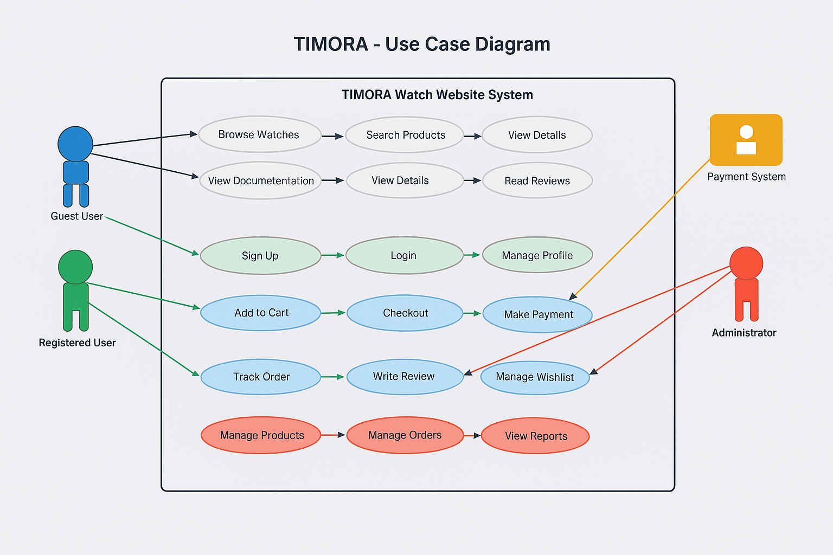

Flow chart Diagram

